RETAIL INVENTORY ANALYSIS DASHBOARD
Project Report
Prepared By
[Shahejan khan]
Tools Used
Power BI
Microsoft Excel
DAX (Data Analysis Expressions)
Project Duration – 45 Days
[Month Year – Month Year]

1. Executive Summary
The Retail Inventory Analysis Dashboard is an interactive business intelligence solution developed in Power BI to help retail organizations monitor sales performance, profitability, inventory status, customer behavior, and regional trends.
The dashboard transforms raw retail transaction data into meaningful insights through interactive visualizations, KPIs, drill-through analysis, tooltips, and business commentary. The project enables decision-makers to identify opportunities, reduce inventory-related risks, and improve overall business performance.

2. Business Problem
Retail organizations generate large volumes of transactional data daily. Without proper analysis, management faces challenges such as:
Difficulty tracking sales performance.
Excess inventory or stock shortages.
Limited visibility into profitable products.
Lack of understanding of customer purchasing behavior.
Inability to quickly identify underperforming regions and categories.
The objective of this project is to convert raw retail data into actionable insights that support business decision-making.

3. Project Objectives
The key objectives of this project are:
Analyze sales performance across categories and regions.
Monitor inventory health and product movement.
Evaluate profitability by product and category.
Identify top-performing and underperforming products.
Understand customer purchasing patterns.
Provide management with real-time business insights.
Improve decision-making through interactive dashboards.

4. Dataset Overview
The dataset contains retail transaction information including:
Column Name | Description
Order ID | Unique order identifier
Order Date | Date of transaction
Customer Name | Customer information
Product Name | Product purchased
Category | Product category
Sub-Category | Product sub-category
State | Sales location
Sales | Revenue generated
Profit | Profit earned
Quantity | Units sold

5. Data Preparation
Data preparation activities included:
Removing duplicate records.
Handling missing values.
Standardizing data formats.
Validating numerical fields.
Creating relationships between tables.
Building a clean data model.
Excel and Power Query were used for data transformation and cleaning.

6. Data Modeling
A structured data model was created in Power BI.
Key components:
Fact Table containing sales transactions.
Dimension Tables for products, customers, and locations.
Relationships established between tables.
DAX measures created for KPI calculations.
7. Dashboard Pages
Page 1: Executive Overview
Purpose: Provide a high-level summary of business performance.
KPIs:
Total Sales, Total Profit, Total Orders, Profit Margin
Features: KPI Cards, Interactive Slicers, Business Commentary
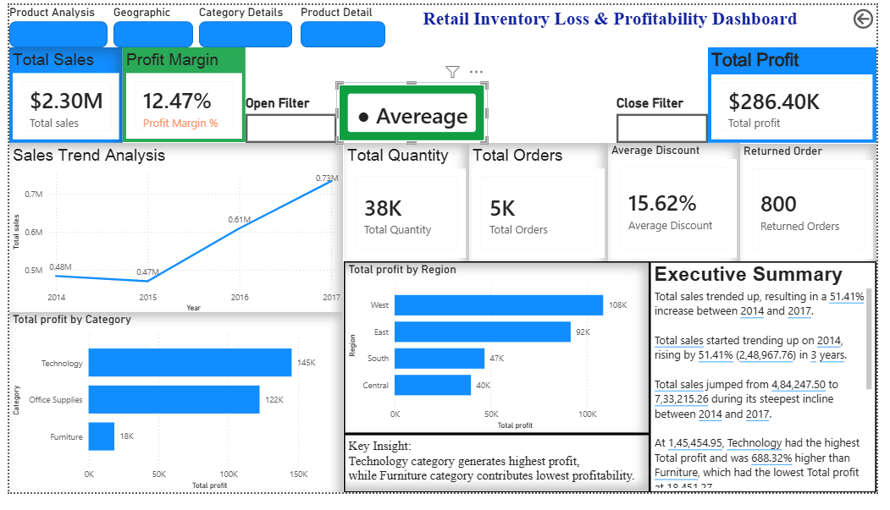
Page 2: Sales Analysis
Purpose: Analyze revenue trends and sales performance.
Visualizations:
Monthly Sales Trend, Category-wise Sales, Sub-Category Performance, Top Products
Insights:
Identify best-selling products.
Understand seasonal sales patterns.
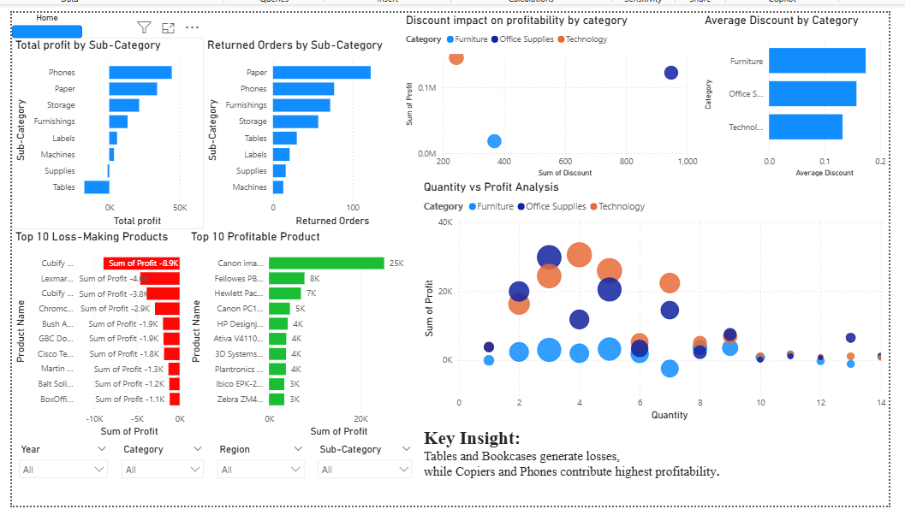
Page 3: Category Details
Purpose: Provide drill-through analysis for categories.
Features:
Category KPIs
Product-Level Breakdown
Detailed Performance Analysis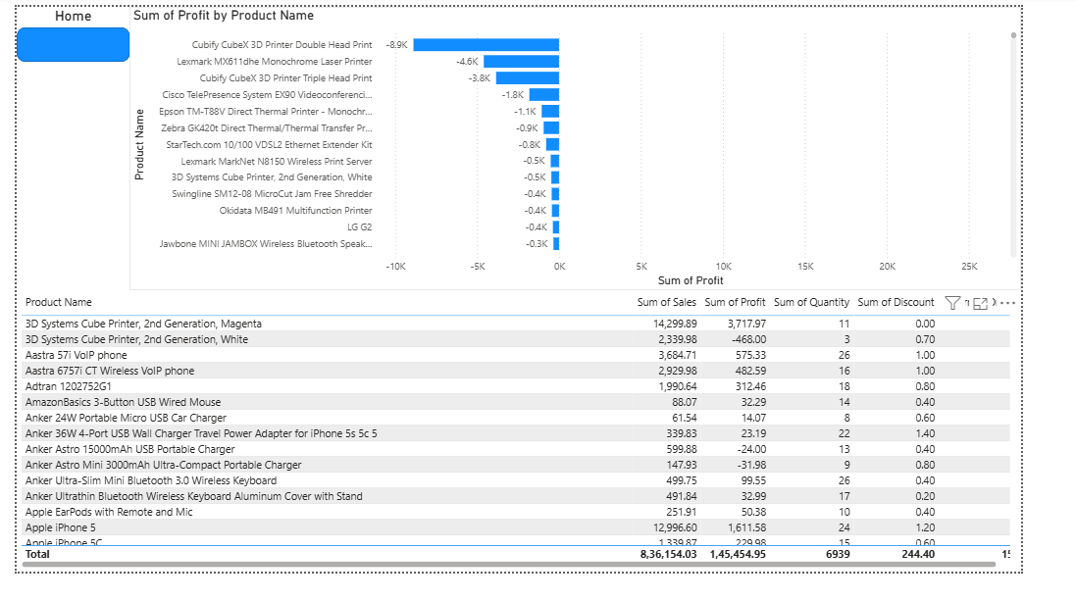

Page 4: Regional Analysis
Purpose: Evaluate geographic performance.
Visualizations:
State-wise Sales
Regional Profitability
Geographic Comparisons
Benefits: Identify strong and weak markets.
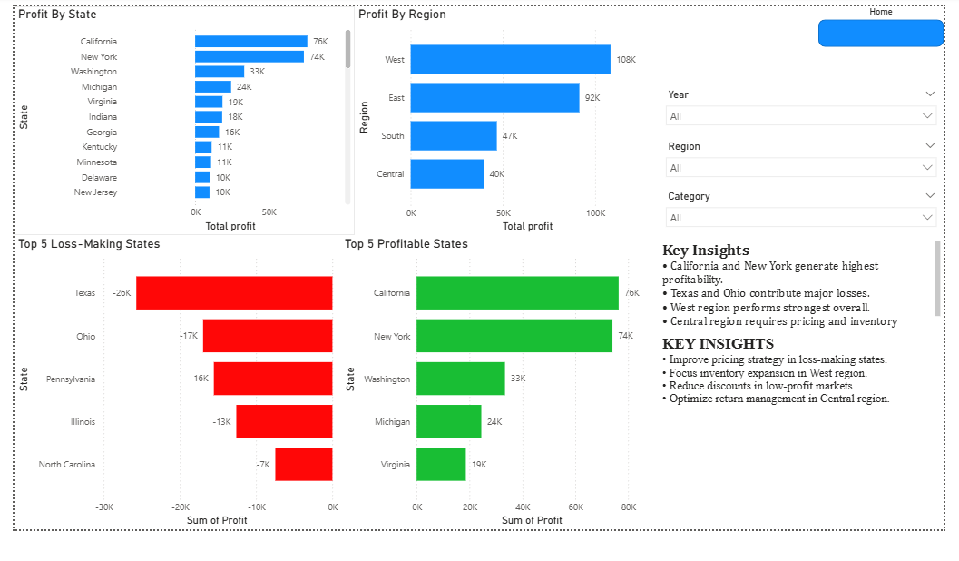

Page 5: Customer Analysis
Purpose: Understand customer behavior.
Visualizations:
Customer Revenue
Order Frequency
Top Customers
Benefits:
Support customer retention strategies.

Page 6: Product Performance
Purpose: Analyze product profitability.
Visualizations: Top Performing Products, Lowest Performing Products ,Profit Contribution Analysis
Benefits: Improve product portfolio decisions. 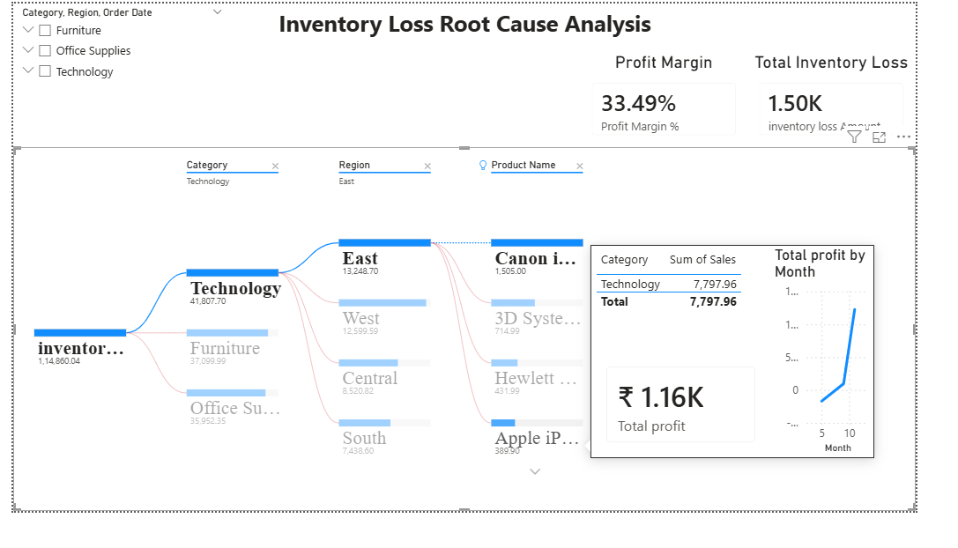
Page 7: Tooltip & Business Insights
Purpose: Provide contextual business commentary.
Features: Dynamic Tooltips, KPI Explanations, Interactive Insights
Benefits: Improve dashboard usability, Support faster interpretation.
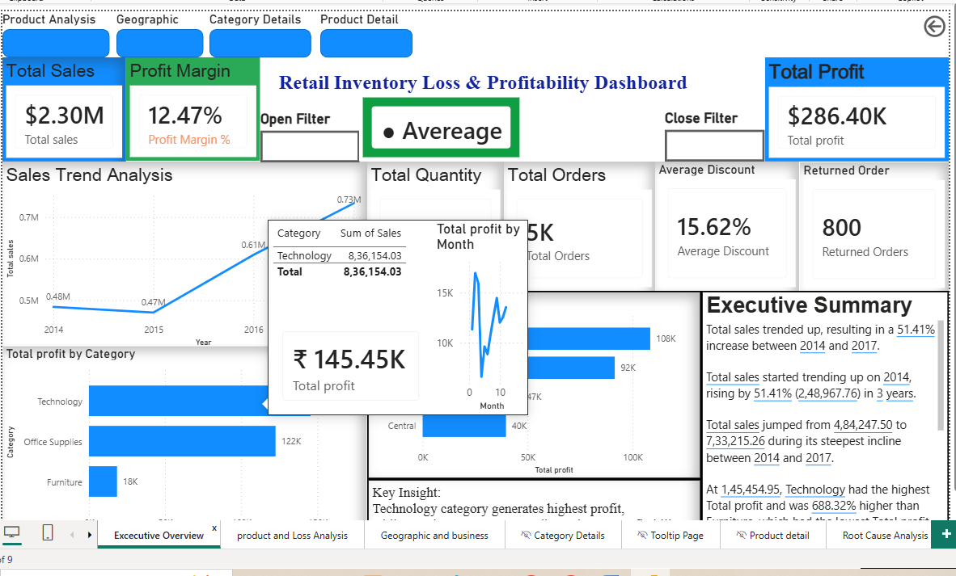
8. DAX Measures Implemented
Examples of measures created:
Total Sales
Total Profit
Total Orders
Profit Margin %
Average Order Value
Dynamic KPI Indicators
These measures enabled advanced business analysis and interactive reporting.
9. Advanced Features Implemented
The dashboard includes:
KPI Cards
Slicers
Drill Through
Tooltips
Bookmarks
Dynamic Navigation
Show/Hide Filter Panel
Conditional Formatting
Business Commentary
Mobile Layout Optimization

10. Key Business Insights
The dashboard helps answer critical business questions:
Which categories generate the highest sales?
Which products contribute most profit?
Which states drive maximum revenue?
Which products require inventory attention?
How are sales trending over time?
Who are the most valuable customers?
Which regions need performance improvement?
11. Business Benefits
The solution provides:
Faster decision-making.
Improved inventory visibility.
Better sales monitoring.
Enhanced profitability analysis.
Increased operational efficiency.
Interactive and user-friendly reporting.
12. Conclusion
The Retail Inventory Analysis Dashboard successfully transforms retail transaction data into meaningful business insights. Through the use of Power BI, DAX, and Excel, the project delivers an interactive reporting solution that supports inventory management, sales optimization, customer analysis, and strategic decision-making.
This project demonstrates practical Business Intelligence, Data Analysis, Dashboard Design, and Business Analyst skills suitable for real-world retail environments.

- Skills Demonstrated
- Power BI Dashboard Development
- Data Modeling
- Data Cleaning
- DAX Calculations
- Business Analysis
- KPI Development
- Data Visualization
- Inventory Analysis
- Sales Analytics
- Report Automation

